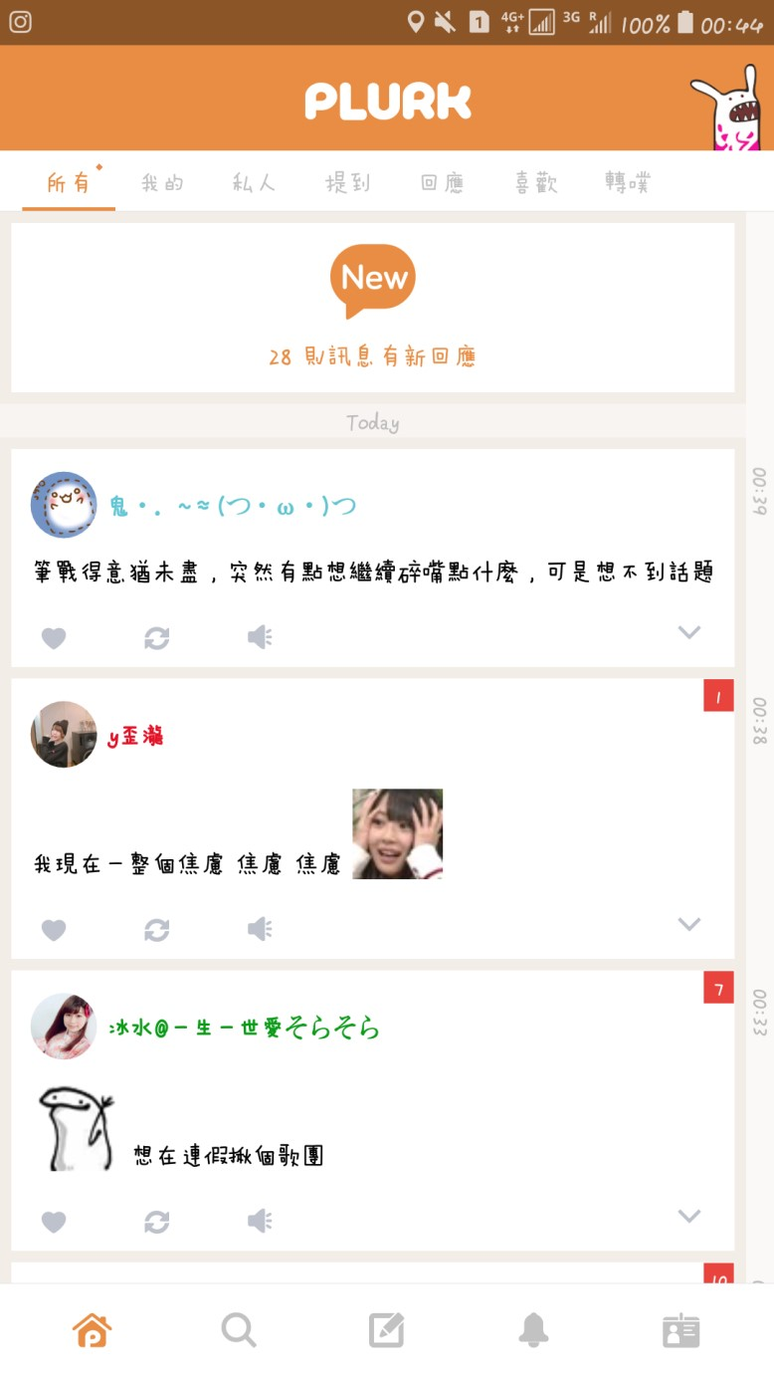

B

ackground Status Bar

Segmented Controls

(

Control What message to read

)

Page Controls

New responses icon

(

To see the latest responses

)

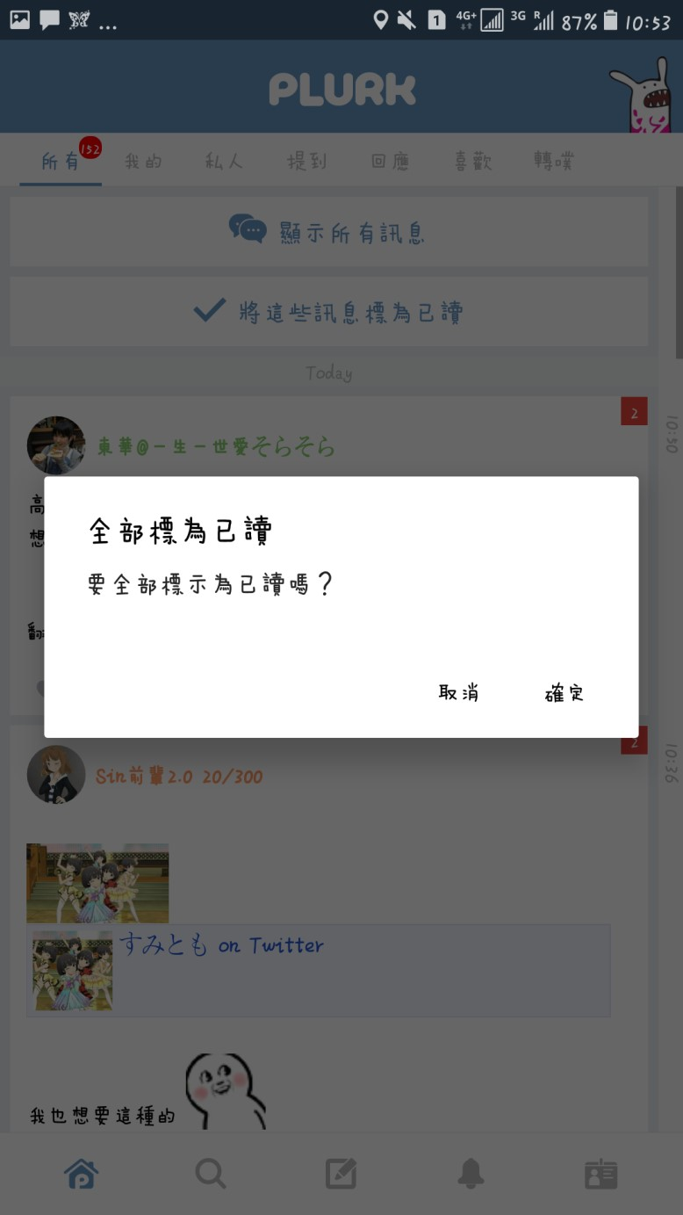

Ale

rts

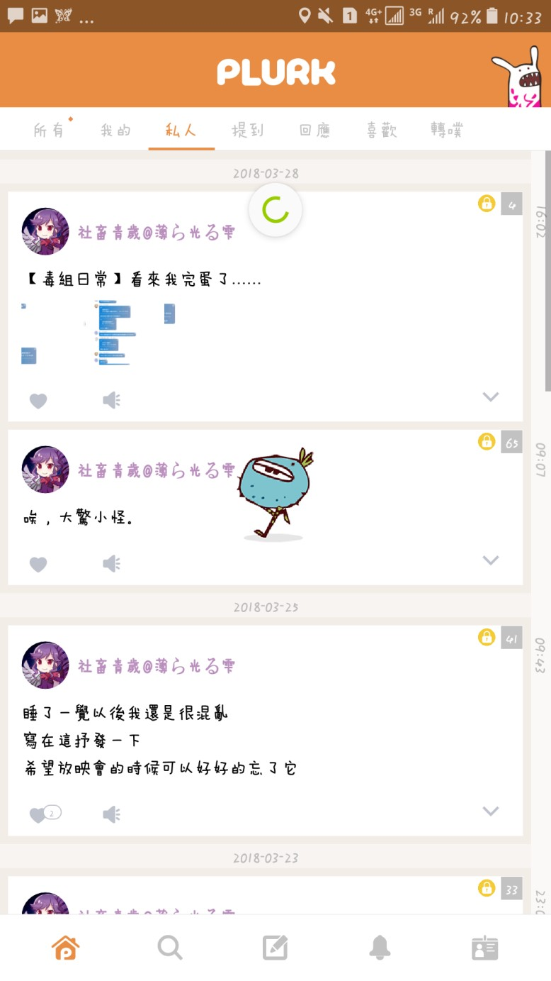

Prog

ress Indicator

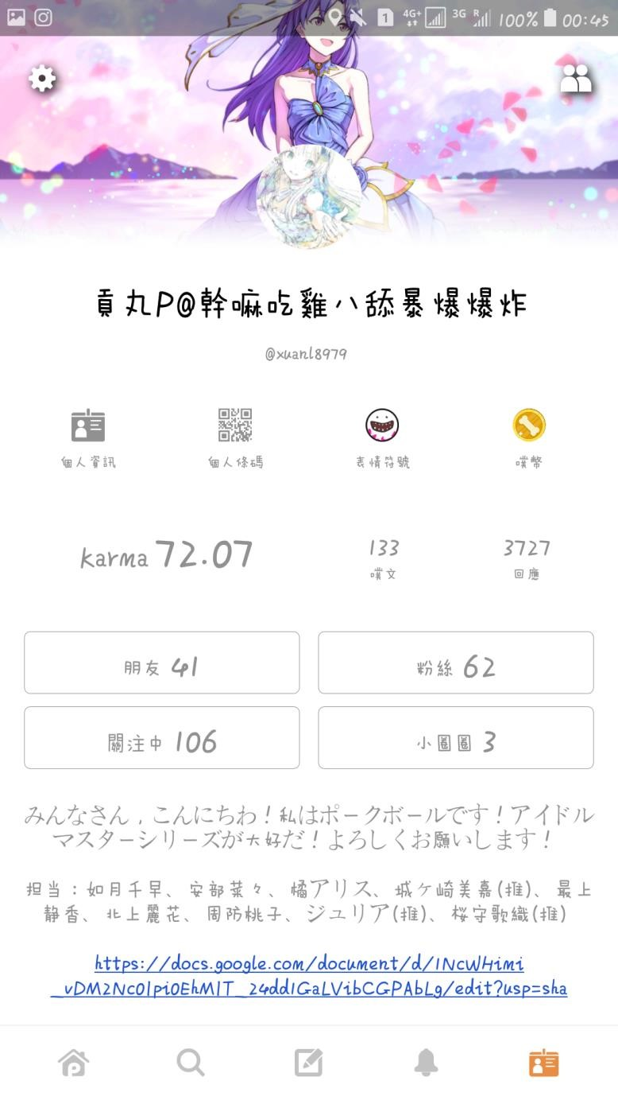

Tool Bar

Tool Bar

T

ab

Bar

Back Icon

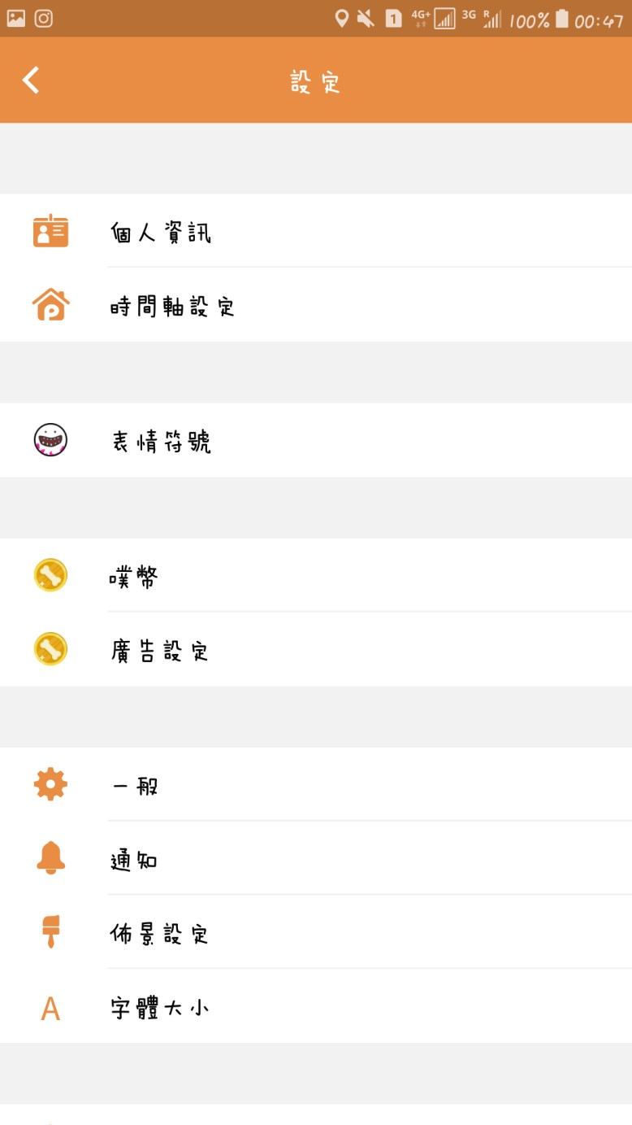

App Bar

Tool

Bar

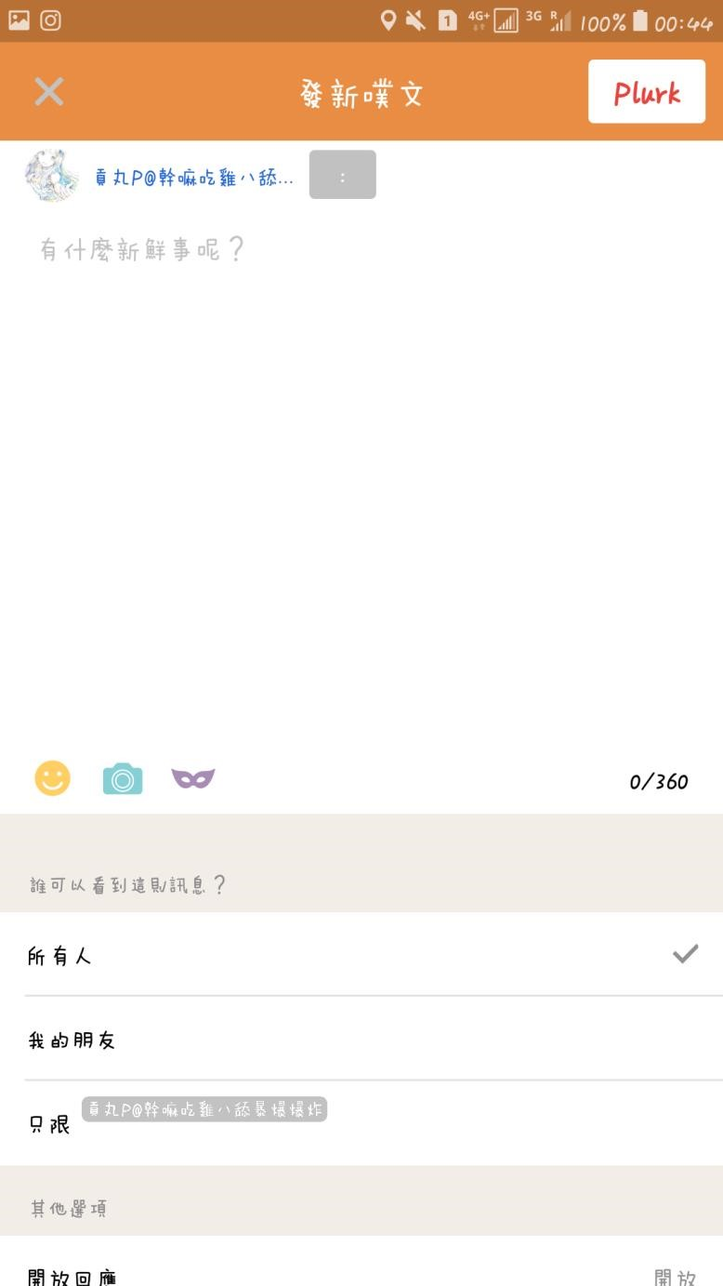

App Bar

Br

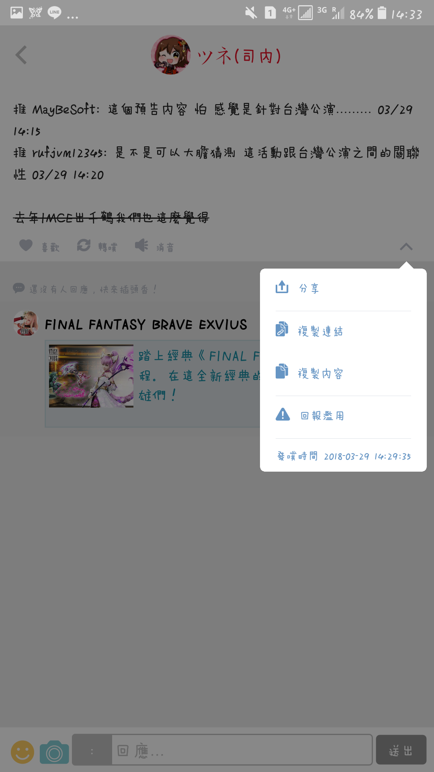

Cancel

Icon

Post

Icon

Tool

Bar

Tool

Bar

Hint

S

tyle

icon

(

Change Post Style

)

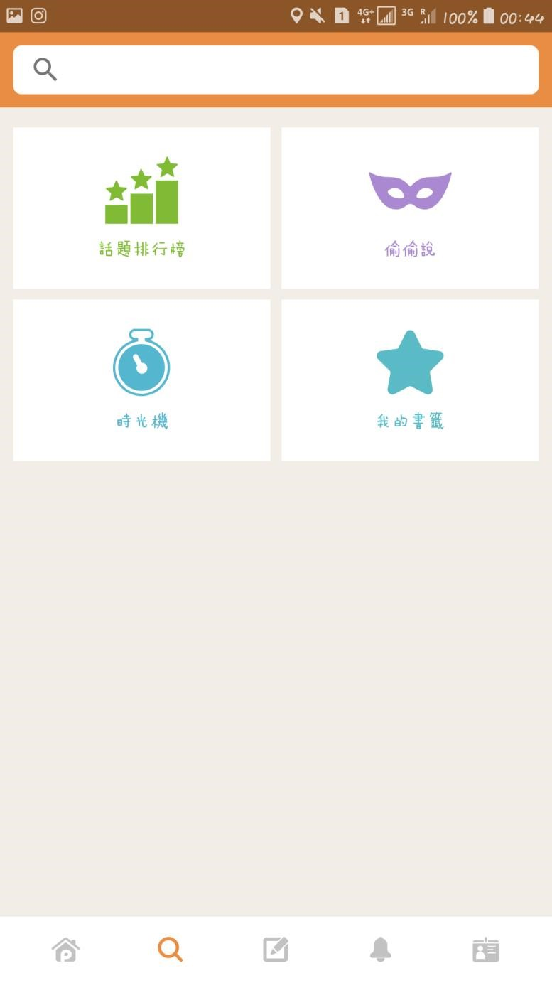

Search

Bar

Tab

Bar

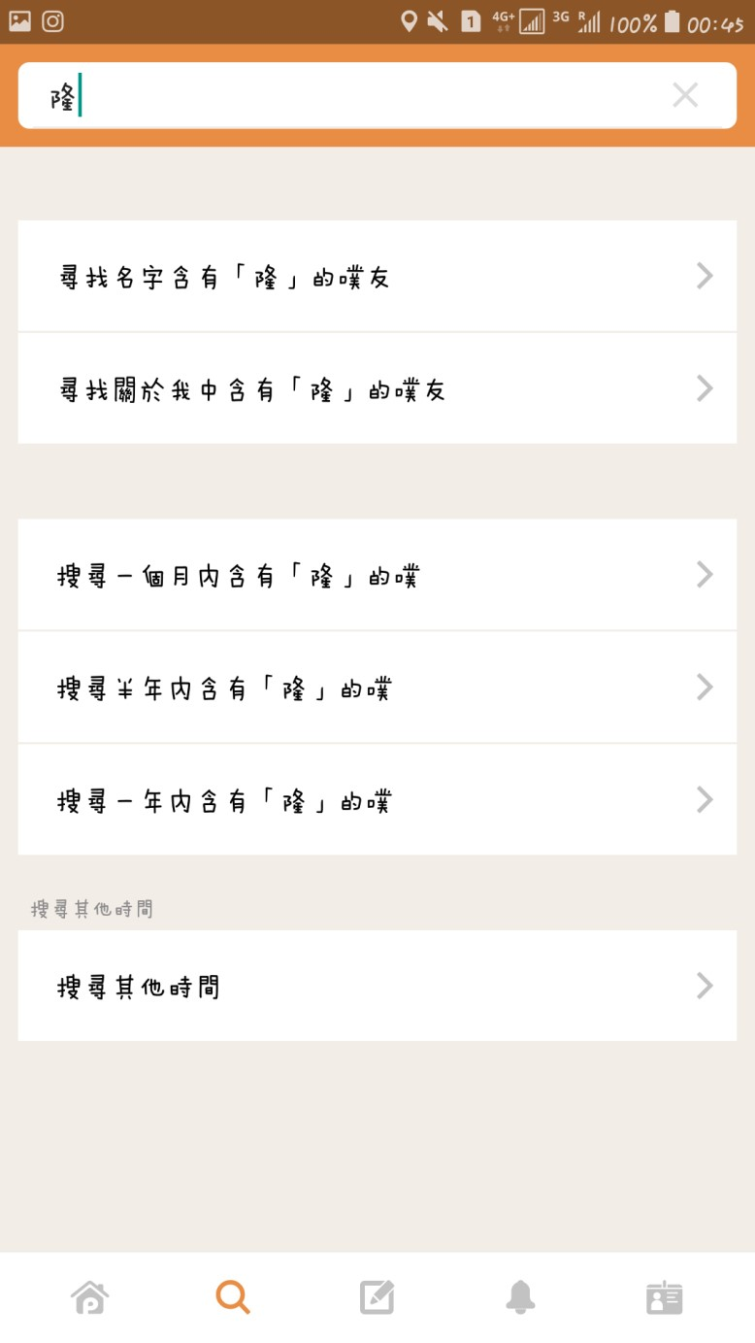

Clean Button

Search way bar

(

Choose how to search

)

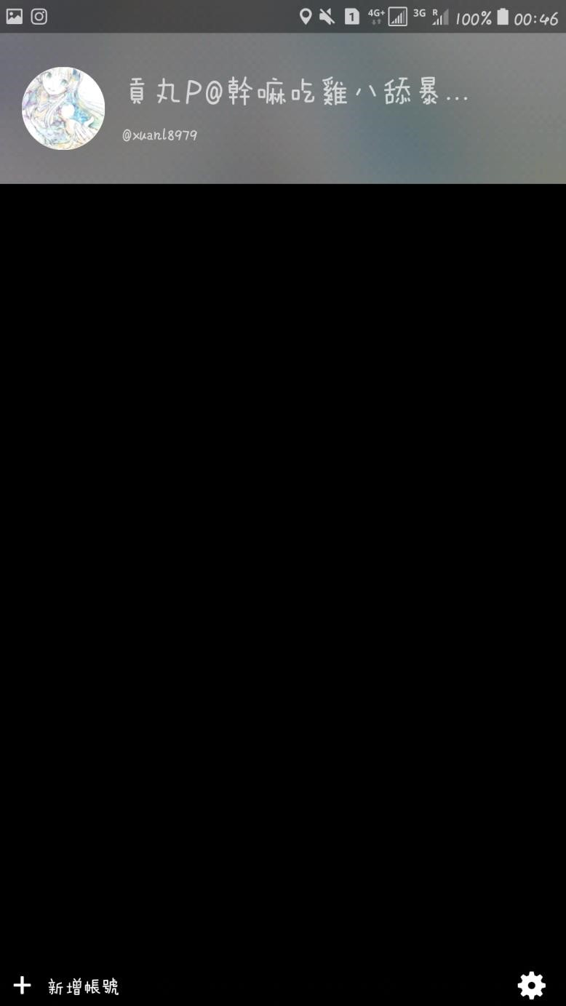

Tool

Bar



Delete Icon

Confirm

Icon

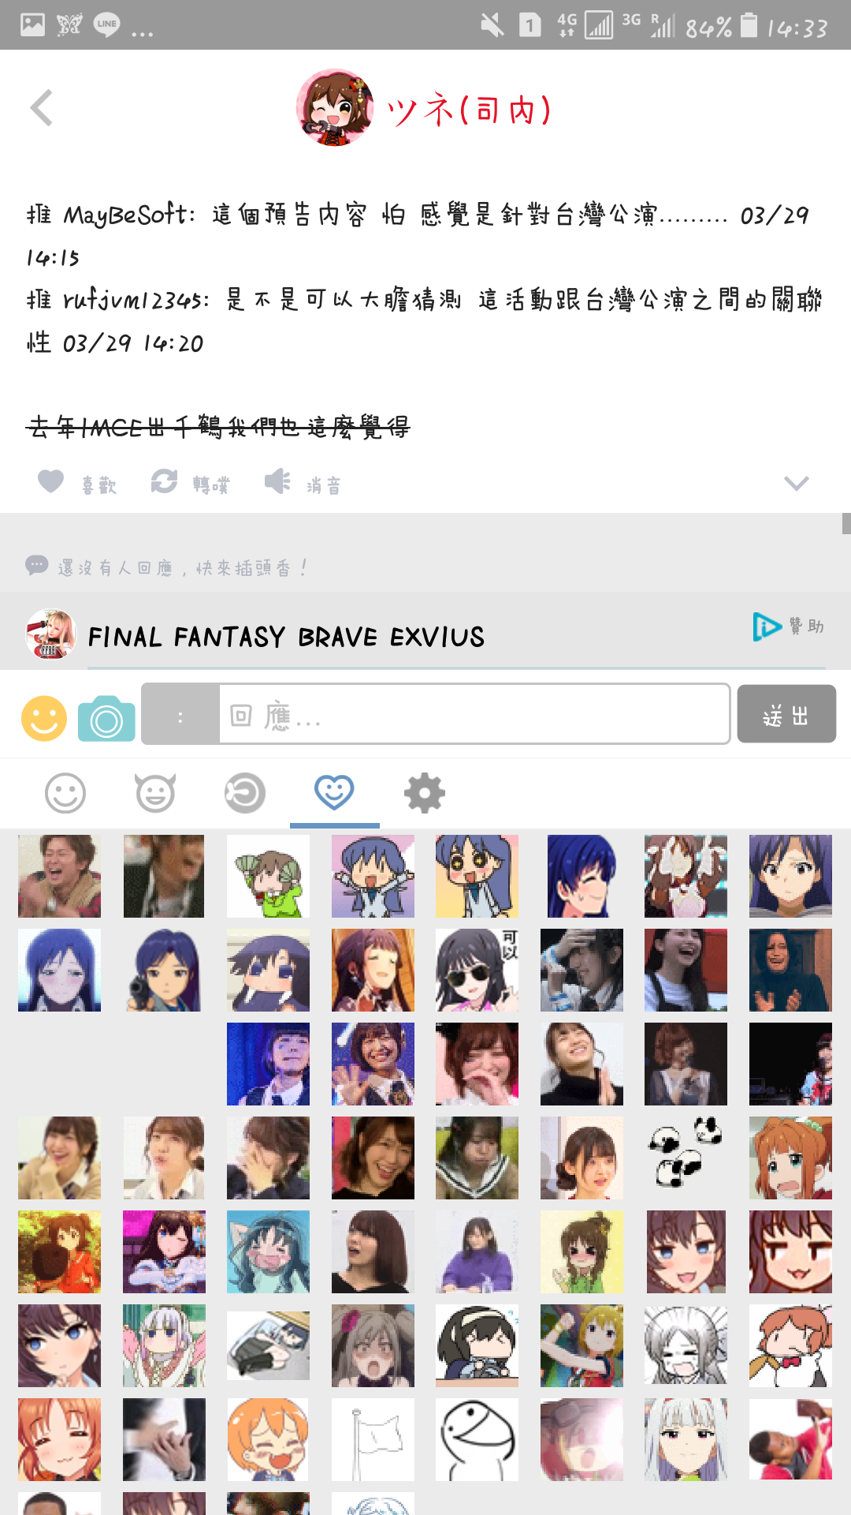

Page control

Tool bar

Tool bar

Back icon



Tool bar